
KENYA CERTIFICATE OF SECONDARY EDUCATION

DOCUMENTATION

KCSE COMPUTER STUDIES PROJECT 2023 (451/3)

NAME: ………./…………

SCHOOL CODE: ` ………………./……

INDEX NUMBER …………………………

PROJECT TITLE: MARINGO SPORTS CLUB SYSTEM

YEAR OF EXAMINATION: 2023

SCHOOL: ……………………./………….

DECLARATION

STUDENT’S DECLARATION
This project entitled MARINGO SPORTS CLUB SYSTEM and presented by …………………… to the Kenya National Examinations Council is my own creativity and original work. There were no external assistance provided from any illegal party and any illegal means. All rights reserved. The publication has copyright to restrict any reproduction, storage or editing of the work without assistance from the owner.

CANDIDATE NAME: __________________________________________________

DATE:__________________________________________ SIGN:______________

SUPERVISOR DECLARATION
I do declare that this work was done under my supervision.

SUPERVISOR: __________________________________________________

DATE:__________________________________________ SIGN:______________

PRINCIPAL DECLARATION
I thereby declare that this project was done by the student and personal work without assistance
.PRINCIPAL NAME: ____________________________________________________

DATE:__________________________________________ SIGN:______________

DEDICATION
I would like to sincerely dedicate this project; Maringo Sports Club System to my beloved parents……….., my siblings, my friends: ……., …….. and …….
More thanks to my beloved computer studies teacher …….. and our beloved Principal /…./…….
Above all, all praises be unto the Almighty for enabling me to reach this far.

ACKNOWLEDGEMENT
I would like to acknowledge the contribution of the following personalities in making of my project a success.
My parents who bought me a Personal Computer to aid me complete and do research on my project in time
- My siblings for providing me with an adequate and peaceful environment to complete my project in time.
- My computer studies teacher ……….. for his advice and guidance not forgetting her teachings and the principal Mr. /…./…….. for ensuring that we get all the required materials to aid us in success of the project.
- The Kenya National Examination Council for providing us with the opportunity to express our full potential in creativity in enhancing the technology arena of our country.

ABSTRACT
As a result of abrupt shifting of the world today’s technology, with inventions of complex systems and technology applications. Solving problems through use of electronic data processing methods has greatly evolved.
After a long negation with several sport organizations, I resolved to come up with a computerized system that will enhance the performance of many sports oriented organizations for better competence in today’s market.

TABLE OF CONTENTS
Table of Contents
KENYA CERTIFICATE OF SECONDARY EDUCATION COMPUTER 2023 (451/3) 1
NAME: ………./………… 1
SCHOOL CODE: ` ………………./…… 1
INDEX NUMBER ………………………… 1
PROJECT TITLE: MARINGO SPORTS CLUB SYSTEM 1
YEAR OF EXAMINATION: 2023 1
SCHOOL: ……………………./…………. 1
DECLARATION 2
STUDENT’S DECLARATION This project entitled MARINGO SPORTS CLUB SYSTEM and presented by …………………… to the Kenya National Examinations Council is my own creativity and original work. There were no external assistance provided from any illegal party and any illegal means. All rights reserved. The publication has copyright to restrict any reproduction, storage or editing of the work without assistance from the owner. 2
CANDIDATE NAME: __________________________________________________ 2
DATE:__________________________________________ SIGN:______________ 2
SUPERVISOR DECLARATION 2
SUPERVISOR: __________________________________________________ 2
DATE:__________________________________________ SIGN:______________ 2
PRINCIPAL DECLARATION 2
DEDICATION 3
ACKNOWLEDGEMENT 3
ABSTRACT 3
CHAPTER ONE 6
INTRODUCTION 6
CHAPTER TWO 7
SYSTEM ANALYSIS 7
THE EXISTING SYSTEM 7
❖ Increase the lifespan of the data kept 7
2.4 FACT FINDING 11
2.5 FEASIBILITY STUDY 13
2.6 SYSTEM REQUIREMENTS SPECIFICATION 15
CHAPTER THREE 16
TABLE DESIGN 17
INPUT DESIGN 22
RELATIONSHIPS 29
OUTPUT DESIGN 29
32
TABLE DESIGN 33
CHAPTER 3 36
System Construction 36
ENTITY-RELATION DIAGRAM (E-DIAGRAM 37
CONSTRUCTION OF MARINGO SPORTS CLUB SYSTEM 38
SETTING REFERENTIAL INTERGRITY 41
CONSTRUCTING DATA ENTRY AND USER- INTERFACE FORMS (INPUT DESIGNS) 41
Advanced forms 43
CREATING REPORTS (OUTPUT DESIGNS) 44
DATABASE SECURITY AND STARTUP OPTIONS. 45
CHAPTER FOUR 47
TESTING AND IMPLEMENTING THE SYSTEM 47
TROUBLE SHOOTING DATA ENTRY AND RELATED ERRORS 47
CHAPTER FIVE 48
USER MANUAL 48
PROCEDURE FOR GENERATING OUTPUTS 49
CHAPTER SIX 50
MISCELLANEOUS 50
APPENDICES OF THE PROJECT 50
BIBLIOGRAPHY 50

CHAPTER ONE

INTRODUCTION

1.1 BACKGROUND INTRODUCTION
Sporting is the art of physical exertion and skill in which an individual or a team competes against another or others for entertainment or leisure, where an individual or a group activity pursued for exercise or pleasure, often involving the testing of physical capabilities and taking the form of a competitive game such as football, tennis, etc.
Maringo Sports Club System is a computerized system whose aim to improve the quality of services offered by the company for better competence in the world market.

Some of the services offered by the company and have been automated include:
- Generation of reports.
- Calculating total income for the company.
- Computes transport earning.
- Computes total income from training.
- Computes payments made to PLAYERs.
- Computes total sales to clients.

This documentation contains elaborate user manual to help the end users to operate the system with minimal.

CHAPTER TWO

SYSTEM ANALYSIS

2.1 PROBLEM DEFINATION

THE EXISTING SYSTEM
Having visited the system used by the organization, I realized that there are several challenges experienced by the PLAYERs based on the system they use to carry out their operations to serve their clients.
The system required a lot of time since it involves a lot of writing calculations and also consumes a lot of space since records were being stored on handwritten papers thus affecting their operations.
The system was expensive to maintain and use since it involves use of pens in writing which increased the cost of the company.
The system was also assessable by strangers hence lacks confidentiality and privacy.
It was difficult to back up data since files were scattered.

2.2 OVERVIEW OF THE EXISTING SOFTWARE
The present system is manual where records of players and all other games are recorded on papers using a pen. All calculations are done using non-scientific calculators. To produce various records in the organizations, the records have to be summarized on a single sheet before surrendering it to the company manager.

2.3 OVERVIEW OF THE PROPOSED SYSTEM
After a keen study on the existing system, there were many challenges experience by the company as it was rigid. The proposed system will greatly improve the performance of the company in the sense that it will be able to cater the challenges experienced by the company.

2.3.2 OBJECTIVES OF THE PROPOSED SYSTEM

Increase the lifespan of the data kept
- Reduce the amount of money used to buy bulky materials to store information
- Reduce the rate at which data is incorrectly entered
- Increase the speed of data input in the organization
- Perform all the organizations transactions and to provide output to the company
- Follow up with the company’s progress in a summarized way

2.3.3 ADVANTAGES OF THE PROPOSED SYSTEM
The new computerized system has many advantages that outweigh the current manual system in that;
      - Faster and more reliable processing speed – There is faster processing of data during the registration of players and very few hitches may occur
      - High data integrity is achieved- Data that is fed into the system passes through a series of integrity rules and checks tom ensure that the data stored is compatible and useful
      - High security of data stored in the system – Several security features have been designed along with the program that will ensure strict warnings are given during the manipulation of data that is already store in the system
      - Time Saving- The system consist of various lookup fields and wizards which guide the user during the data entry and manipulation which serve to provide frequently entered data which makes it easier to register a new player.
      - Informative and detailed summary reports are easily generated – High quality and informative reports that may show trends and emerging issues are easily generated after a few steps without any manual calculations hence severs the planning needs
These are some of the reasons why the system is to be developed.
The proposed system will:
- Reduce the erroneous nature of the existing system.
- Ensuring data is kept confidential and data integrity was observed by all means.
- Automatic operation of the system making it competes well in the world market.

2.3.4 SCOPE OF THE SYSTEM
The system will be able to carry out all the transactions of the company and provide appropriate reports on the sales.
The system will not be able to show the working place of the total income and track lost goods.
The proposed computerized system will perform the following functions;
Generate:
- Maintain details of the club members and their roles;
- Maintain details of sports in the club;
- Maintain records of items in the store;
- Maintain records of items purchased and their subsequent stock levels;
- Maintain records of all facilitation fees for all sports events;
Compute:
- Total membership fee;
- Discounted prices;
- Total amount for items bought;
- Surcharged fee for lost or damaged equipment;
- Facilitation fee;
- Patrons’ commission;
- Total income for the club.

2.3.5 DISADVANTAGES OF THE PROPOSED SYSTEM
Besides that this system will improve the efficiency of the company, it will also have the following limitations:
- It will require computers and source of electricity.
- Maintenance cost is high.

2.3.6 COSTS AND BENEFITS ANALYSIS
The costs of implementing and running the Automated System have been clearly summarized in the following table:
System Development | 250,000/=
Annual Running and Maintenance | 50,000/=
Annual Additional Upgrades and others | 75,000/=

Table 2.1 Implementation cost Analysis
The total cost that would be possibly incurred in the total lifespan is:
=250,000 + {(50,000 + 75,000) * 10}
= 1,500,000/=
There will be benefits os savings from properties Virtual Registration Forms which will encounter to 30,000/=

2.4 FACT FINDING
Maringo Sports Club Organization responded and gave an okay to start developing the system,. After signing the contract, the next step was to discover the requirements of the new system through data gathering. The data gathering mission was fulfilled out through

2.3.7 METHODS OF DATA COLLECTION
I used the following methods:
- Conducting Interviews.
- Questionnaires
- Document Review
- Observation
- Document Review
A number of documents were viewed. These included printed workbooks, inventory files, invoices, orders, books, sales report and ledger books. There is a lot of redundancy in data administration.
- Observation
I observed the information recording method used and how the calculations were made and to my recognition that the data entry method was by use of pen which was prone to a lot of errors.
- Interviews
I used a sample of interviews as shown below;
Table 2.2 Interview table
INTERVIEW TITLE
BRIEF INTRODUCTION Interviewer…………………………
Interviewee………………………………….
Interviewer: Hello.
Interviewee: Hello welcome into my office.
Interviewer: Please call me Optimums. I would like to ask you a few questions about Maringo Sports Club System?
Interviewee: Yes you can.
Interviewer: How long have been working in this organization?
Interviewee: 5 years.
Interviewer; How would you comment on the performance of the
current system

?
Interviewee: It is slow.
Interviewer: How long does it take for one to work with.
Interviewee: About 2 hours.
Interviewr :Do you recommend the system to be changed and why?
Interviewee: Yes.so as to improve the efficiency of the company.
Interviewer: Thank you for your co-operation.

2.3.8 SUMMARY OF FACT FINDING METHODS USED
The fact finding process was a perfect opener to realize the real problem facing the current manual system. The research work was extensively done to ensure that a suitable system was implemented. The following are reports on the fact finding techniques:
Problems Identified by the Company’s Officials
- The time taken to process a single entry was averagely above 15 minutes
- There was a lot of repetition and data lacked integrity rules during data input
- The amount of money spent to process a single entry in the manual database was an estimated four thousand Kenyan Shilling which make the current system so expensive to use.
- The data kept had a very short lifespan of between 5-10 years
- No Monthly reports and calculation were done since the manual system had no room for data allocation
Problems Identified by the Company’s Officials
- The time taken to finally complete the registration process was beyond limits and was averagely 2 days
- The expenses met during the whole registration process was very high
- The filling forms used were very confusing at times and most did not understand them
In general, the response to the overview of the current system was discouraging and all respondents gave their opinion to change the outlook of the current system in regards of the following;
- Speed of data entry
- Duration of data processing
- Expenses met during registration
- The integrity of data provided

2.5 FEASIBILITY STUDY

2.3.9 ECONOMIC FEASIBILITY
- Cost Estimation
The proposed system would be more economically and reliable to the users. The cost of the development and implementation of the proposed system is estimated as follows:

Table 2.1 Estimated Costs
Development cost | Ksh.500,000
Weekly costs | Ksh. 5,000
Monthly costs | Ksh.20,000
Total life span of the system | 10 Years
Maintenance and repair costs | Ksh.120,000
Total life time costs | Ksh.2,000,000

- Benefit Estimation
Amount due to error reduction: Ksh 50,000
Total benefit / Ksh 50,000/=

Table 2.1 Benefits of the new system
Profits from increased no. of clients | kSH.25,000,000
Cost saved on material equipment | Ksh.2,000,000
Cost saved from correct account data | Ksh1,500,000
 | Ksh.28,500,000
TOTAL PROFIT FROM THE SYSTEM | Ksh.28,500,000-2,000,000
 | =Ksh27,500,000

2.4.1 SCHEDULE FEASIBILITY

Table 2.1 Schedule Feasibility
Problem Definition and recognition and documentation | 3weeks
System Analysis and documentation | 3 weeks
System Design and documentation | 2 weeks
System Coding and documentation | 2 weeks
System Construction and documentation | 6 weeks
System Testing and Debugging and documentation | 2 weeks
System Presentation and Implementation and documentation | 2 weeks
The system was developed within 5 months.

2.4.2 OPERATIONAL FEASIBILITY
The system is designed using Graphical User Interface thus more attractive and friendly to use.

2.4.3 TECHNICAL FEASIBILITY.
Technology used to develop this system is readily available in the market and is affordable.

2.6 SYSTEM REQUIREMENTS SPECIFICATION
Some of the processing requirements needed for the system to function effectively include:

2.4.4 INPUT SPECIFICATION
- Name of PLAYERs
- Sale of accessories
- Sale of honey harvesting kit
- Sale of honey extractor

2.4.5 PROCESSING SPECIFICATION
- Calculate payments for the services to PLAYERs
- Calculate payments made to PLAYERs for honey delivery
- Computes total sales to clients
- Compute income from training
- Compute total income for the company

2.4.6 OUTPUT SPECIFICATION
- Generate reports on payments made by PLAYERs
- Generate reports for services to PLAYER
- Generate reports for total income for the company
- Generate reports on transport earnings
- Generate reports for total sale to clients

2.4.7 SOFTWARE SPECIFICATION
- Microsoft Windows 10
- Microsoft office suite
- SmartDav Anti-virus Program

2.4.8 HARDWARE SPECIFICATION
- Computer System
- 128GB Hard disk
- 20GB RAM
- Modem
- Printer

CHAPTER THREE

FIGURE 5 SYSTEM DESIGN
Start
Membership file
YES
NO
YES
NO
YES
Input DOB and other details
YES
YES
YES
NO
NO
NO
Equipment Management Module
Manage Equipments
Main Menu
LOG IN
Registration?
Sales
Membership Report
Stop
Sales Report
Sales file
Display
“You are not eligible”
Age>=12 and Age<=35?
Event Facilitation Module
Calculate Age
Update sales file
Amount Payable =sales- discount
Calculate Discount
Sales>10000?
External Event Facilitation
FIELD NAME | DATA TYPE
Player ID No | Number
First Name | Short Text
Middle Name | Short Text
Last Name | Short Text
Gender | Short Text
Kin’s Name | Short Text
Date of Birth | Date and Time
Date of Registration | Date
Location | Short Text
Mobile Number | Number
Game Played | Short Text
Weight | Short Text
Height | Short Text

TABLE DESIGN

Figure 6 Player Registrations.

Figure 7.Player Table
FIELD NAME | DATA TYPE
Player ID No | Number
First Name | Short Text
Middle Name | Short Text
Last Name | Short Text
Email Address | Hyper link
Business Phone | Short Text
Address | Text
City | Short Text

Figure8 3.Product Sales Table
Field Name | Data Type
Sale ID No | Number
Sold To | Short Text
Type of Sale | Short Text
Quantity | Number
Units/Package | Number
Date | Date and Time
Request Transportation | Yes/No

Figure9 4.Product Purchase Table
Field Name | Data Type
PURCHASE ID No. | Number
Supplier ID | Short Text
Purchase Type | Short Text
Quantity | Number
Date Received | Date and Time
Unit Cost | Currency
Payment Method | Short Text
Bank Name | Short Text
Account Name | Number

Figure10 5.Gender Table
Field Name | Data Type
Male | Text
Female | Text

Figure11 6.Games Table
Field Name | Data Type
Game ID | Number
Game Code | Text
Game Played | Short Text

Figure 12 Enrollment Table
Field Name | Data Type
Enrollment ID No | Number
Enrollment Platform Name | Short Text
Enrollment Cost | Currency
Fee | Currency

Figure137.Product Sales Table
Field Name | Data Type
Sale ID | Number
Sold To | Short Text
Type of Sale | Text
Quantity | Number
Unit/Packages | Number
Date | Date and Time
Request Transportation | Yes/No

Figure14 8.Traineees Table
Field Name | Data Type
Trainee ID | Number
Full Names | Short Text
Training | Number

Figure15 9.Trainers Table
Field Name | Data Type
Trainer ID | Number
First Name | Short Text
LastName | Short Text
Email Address | Hyperlink
Business Phone | Number
Date of Employment | Short Text

Figure16 10.Trainings Table
Field Name | Data Type
Training ID | Number
Package ID | Short Text
PLAYER ID | Short Text
Booking Date | Date and Time
Training Date | Date and Time
Played From | Short Text

Figure 17 11. Transportation Table
Field Name | Data Type
Transportation ID | Number
Sale ID | Number
Shipper ID | Number
Ship Address | Short text
Ship City | Short Text
Ship ZIP/Post | Number
Distance | Text

INPUT DESIGN

Figure 20 Player Registration Form
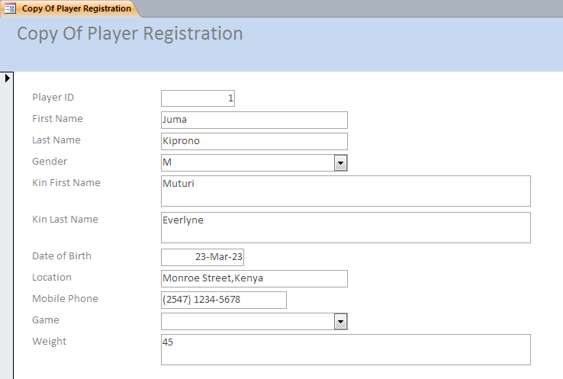

Figure 21 Transportation Table

Client Name ID No Acc No

Supplier Name ID No Acc No

Place Address Date

Item Delivered Type of Vehicle

COST KSH:

Figure 22 Players Form
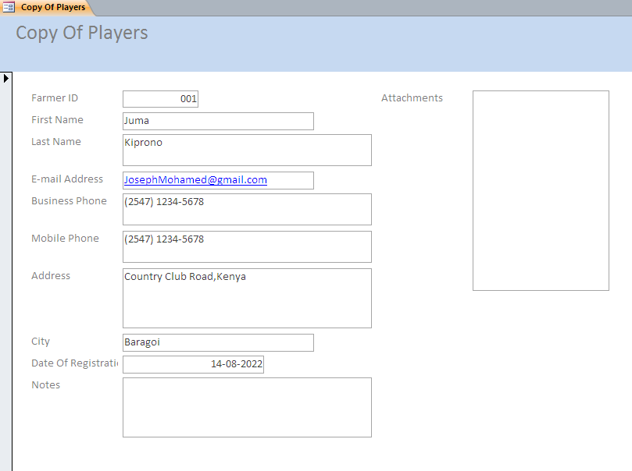

Figure 23 Product Sales Form
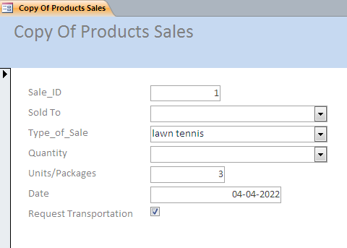
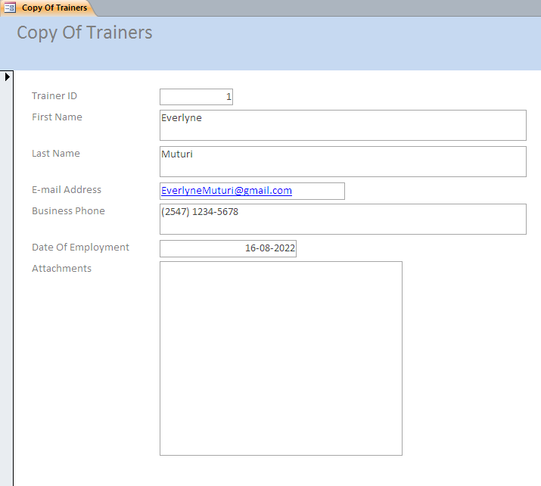

Figure 25 Trainings Form

Figure 24 Trainers Form
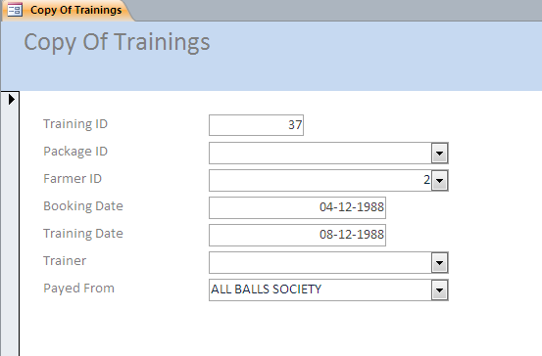

FIGUR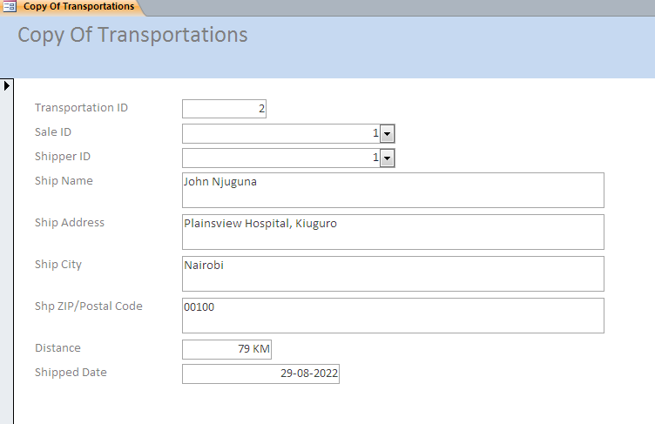

Figure 26 Transportation Form

Figure 27 Captains Form

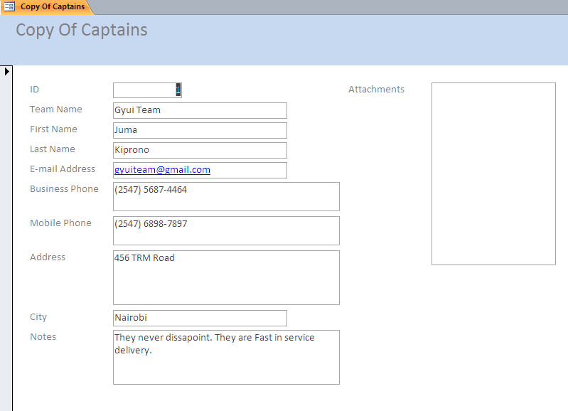

Figure 28 Client’s Sale Form
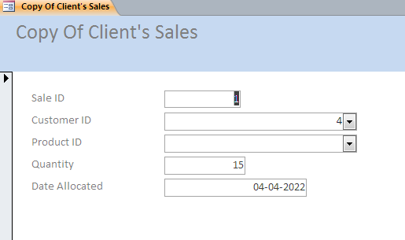

Figure 28 Enrollment Form
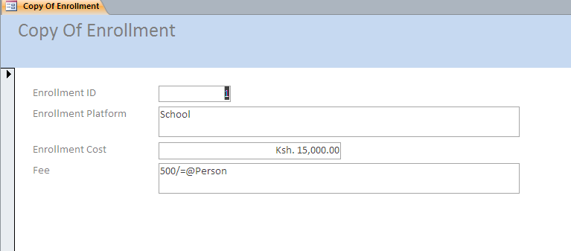
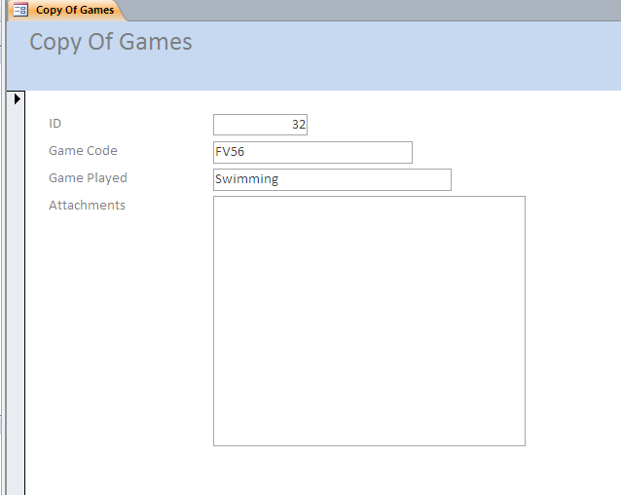

Figure 30 Players Form

Figure 29 Players Form
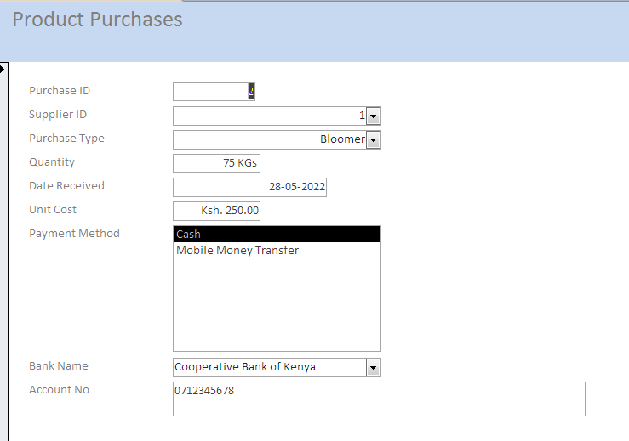

RELATIONSHIPS

OUTPUT DESIGN
Price Per Item 550
Price Per Item 750
Games Short
Price per Item Ksh 2000
Hockey Stick
Price Per Item Ksh 450
Wrapper
Price per Item Ksh 800
T-Shirt
Price Per Item Ksh 1000
Track Suit
Price per Pair ranging between 1000 to 4000/=
Sport Shoes

Socks

Sporting Items
Price Per Item Ksh 250/=

Boomer

FIGURE28 INCOME REPORT
Cancel
Find Records
Save
Close
Company Details
Transport Fees Date

Training Fees

Sale Fees

COMPANY INCOME KSH

FIGURE 29 SALESPERSON REPORT

Salesperson Name ID NO

Place Address

Item Sold COST KSH:
Close
Cancel
Find Record
Save

FIGURE 30 PAYMENT REPORT
Personal Details
Players Name ID NO Acc NO

Mode of Payment Training Fees Delivery Fees
Payment KSH

Close
Cancel
Save
Find Record

FIGURE 32 DELIVERY REPORT
Save
Find Record
Close
Cancel
Find Record
Save
Cancel
Close

Client Name ID NO Acc NO

Supplier Name ID NO

Type of Vehicle Place Address

Items delivered

COST KSH
FIGURE33 ORDER REPORT

FIGURE 34 TRAINING REPORT

Trainee Name Trainee ID NO

Trainer Name Trainer ID NO

Place Of Training Address Date

Period Training Fees

FIGURE35PLAYERS REPORT
Close
Cancel
Save
Find Record
FIGURE 35 PLAYERS REPORT

Players Name ID NO ACC NO

Branch Name Address

Date of Registration

Find Record
Save
Close
Cancel

TABLE DESIGN

Figure 1.1 DELIVERY TABLE
Used to capture data for clients for delivery of item ordered to the final destination.
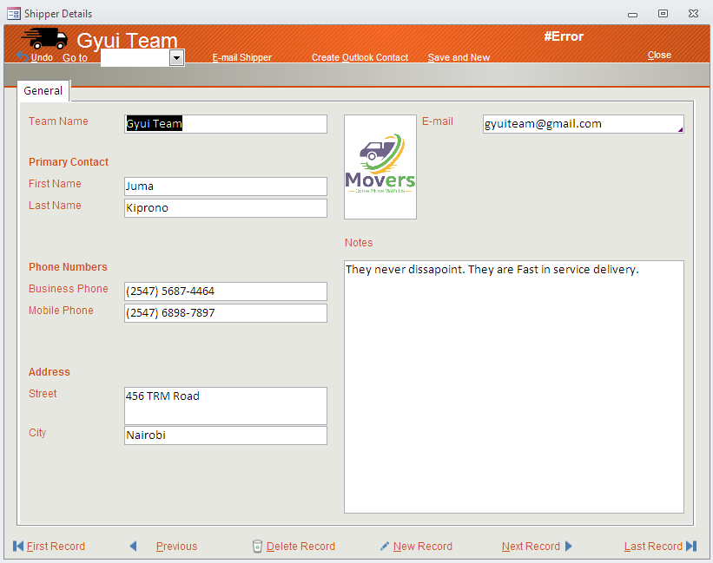

Figure 1.2 PLAYER REGISTRATION TABLE
Used to capture player’s details and maintain their records for reference.
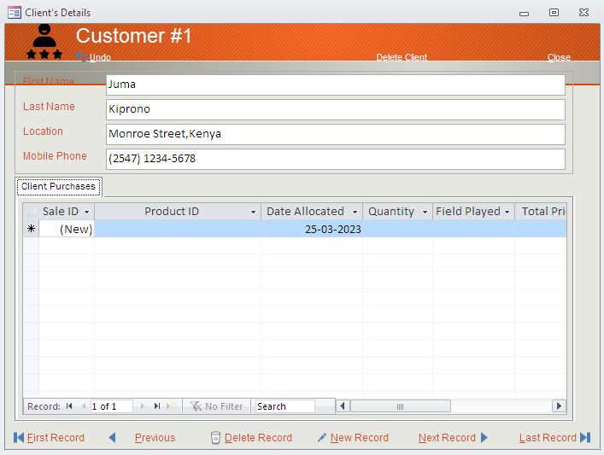

Figure 1.3 PAYMENT TABLE
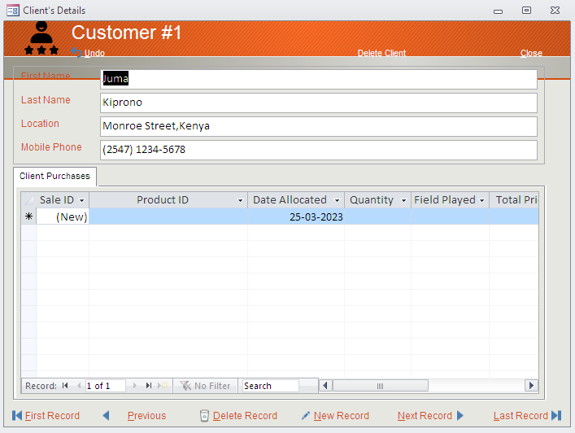

Figure 1.4 PUCHASE TABLE
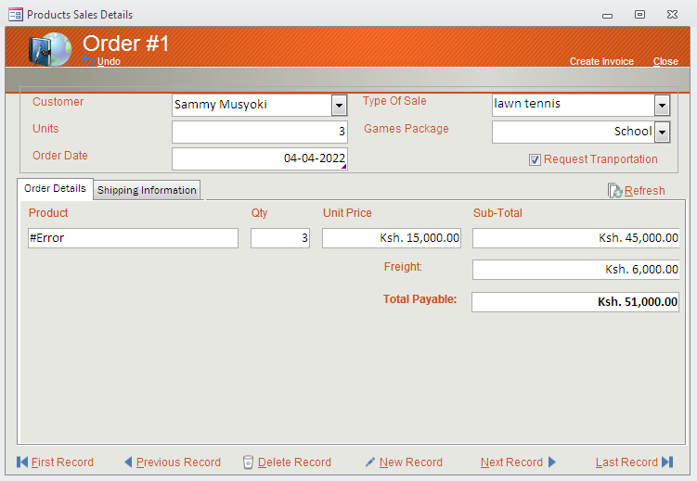

Figure 1.5 SERVICE TABLE
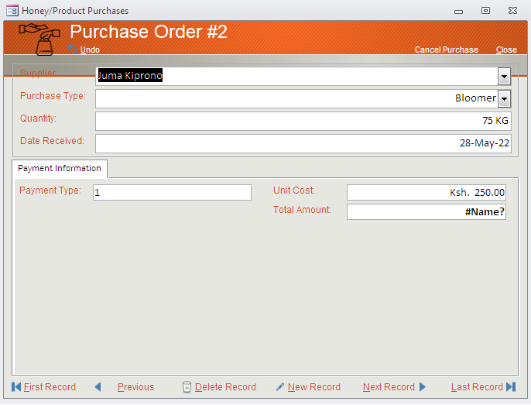

Figure 1.6 TRAINEE REGISTRATION TABLE
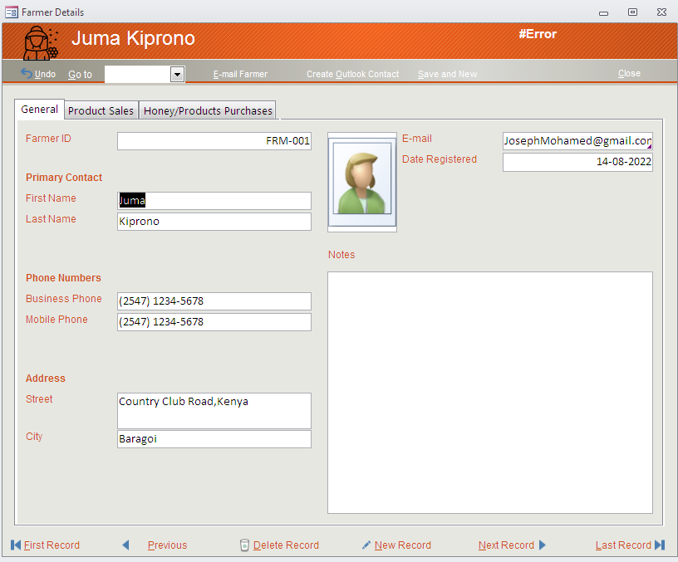

Figure 1.7 TRAINING TABLE
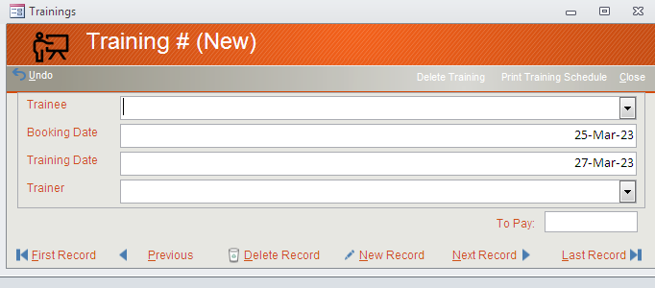

CHAPTER 3
System Construction

3.1 DESIGNING TABLES/FLE STRUCTURES
The following were followed during the design of file structures such as tables to keep database of Maringo Sports Club System.
- Enter the file structure to be constructed i.e. master file.
- Type the size of file in terms of storage space and capacity in order to determine the appropriate storage media such as Hard disk, Diskettes, CDs DVDs, or Flash disk.
Type the method of accessing data e.g. random.
Data structure allows the analyst to produce a view of elements that forms the output. Within the system, the data structure that will be used to store data values of various entities is known as record.
The figures below show a file structure in the design mode for Maringo System.
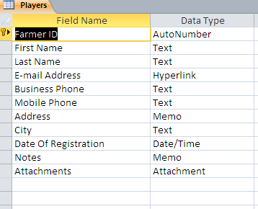
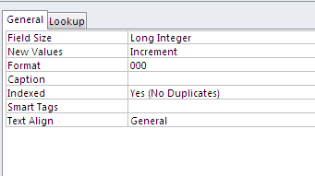
Payment services file structure in design mode

ENTITY-RELATION DIAGRAM (E-DIAGRAM
Some of entities used to construct the system are player registration details, trainee details, making and delivery of orders of clients with respective PLAYERs. The following is a diagrammatic representation on how the records are linked and related.
Store Inventory

Inventory ID
Sporting Item ID
Inventory Item Stock Totals
Date updated Sporting Item

Store Inventory

Sporting Item ID
Sporting Item Price
Sporting Item Condition

Figure 1.8 Showing an E-Diagram

Interpretation
Property accounted for by an individual i.e. Designation and name is determined by the Player ID if the holder is a Player.

HARDWARE AND SOFTWARE REQUIREMENTS
After the system officials had approved the detailed system design it was basic to check for both software and hardware considerations. As a result, the hardware specialists visited several suppliers and dealers of computer accessories and software’s in the region. Part of the conditions used in selecting both the hardware and software included identifying the type of processor and its speed, the memory capacity, warrant, upgradability and compatibility of the hardware with the system and portability. They visited various suppliers in major towns and bought quotations and price lists for most of the required resources as shown.

Requirement | Type |  | Purpose
GUI | Windows 10 |  | Operating System
Microsoft Access | MS Access 15 |  | Designing & coding
Microsoft Word |  | MS Windows 10 | Documentation
Antivirus |  | Kaspersky, Smadav Norton | To detect and scan viruses that may attack the system
Laptop |  | HP | Terminal & development process
Printer |  | Laser HP 1510 Series | Print documentation
Removable storage media |  | External Hard disk | Back up

CONSTRUCTION OF MARINGO SPORTS CLUB SYSTEM
Maringo Sports Club System is relational database in a series of two dimensional tables; the first step in designing the information base is to design tables or files that are related to each other via primary and foreign keys.

SETTING UP INTEGRITY CONSTRAINS
After setting up the database based on the entity relationship diagram, some integrity constraints needed to be in the database to improve accuracy and speed of the system. Examples are lookup fields and data integrity constraints.

CREATING A LOOKUP FIELD
It displays list of acceptable data values that may be entered into a field. This avoids problems of wrong data entry in a field.
To create a lookup field:
- Open the table in design view.
- Select lookup wizard in the data type column of the desired fields.
- Complete the prompts in the lookup wizard.
The figure below shows a process on how to set up a look up for the Player registration in the registration table.
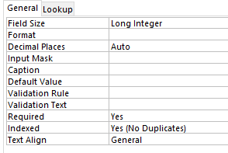
When the table is displayed in datasheet or on form view, you simply select from the list as shown below.

Data integrity constraints
Refer to rules that direct input, changing and deletion of data and records in a database. Some of them include:
- Entity integrity constraints.
- Referential integrity.
- Domain integrity.

Entity integrity
Are rules that govern the composition of the primary key. A primary key cannot contain a null value, it must be unique. Null values are empty spaces in a field that have no data. The table below shows ID Number field (which is a primary key) does not allow duplicates of data or null values.
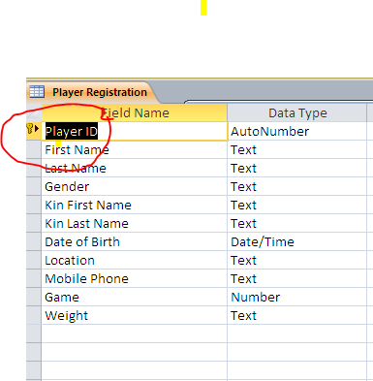

Referential integrity
It directs the nature of one to many relationships between entity tables in the database. All foreign keys in the child table must have a matching record corresponding in the parent table. It can be implemented in the following ways.
- Restricted database: - The system deletes or updates a parent record if there are no fields matching child records.
- Cascaded database: - Cascaded database can delete or update all matching child records when the parent record is deleted. It is a better approach when changing records are updated.

SETTING REFERENTIAL INTERGRITY
The figure shows how to set up referential integrity between PLAYERs name and payment
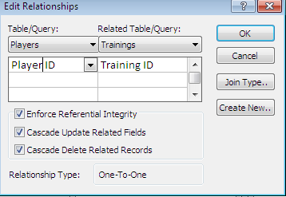

Domain integrity
Domain is used to refer to the acceptable range of data values an attribute contain. This ensures that no field takes a value outside the range of valid data values.

CONSTRUCTING DATA ENTRY AND USER- INTERFACE FORMS (INPUT DESIGNS)
The main purpose of creating forms is to reduce data entry errors. The volume of data to be entered should be reduced, validated and integrity checks such as data type, domain and referential integrity are enforced.
This section examines creating graphical user interface (GUI) forms in Microsoft Access 15 using the appropriate controls and macros.

Primary forms
Forms used to enter data into underlying tables. These include registrations input screen and training period in months.
Factors considered in creating primary forms include:
- The general form properties e.g. record source that is, underlying table.
- Control properties for each of the objects.
- Command buttons and their underlying event steps

PLAYER REGISTRATION INPUT SCREEN
This form has been designed in a columnar layout and it is manipulated with control buttons at its lower end and it is used to enter data and records in the underlying registrations table.
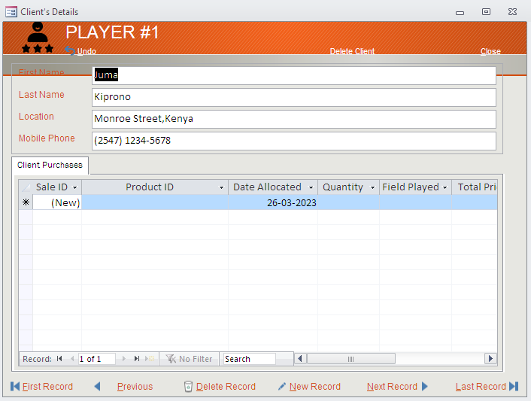

Showing players input screen

Advanced forms
These are more complex forms that are based on underlying queries and unbound controls. These forms provide the user with easy access to and manipulation of data in the underlying tables and other database objects for example registration input screen which extracts its data from the registration table

Data entry and manipulations forms
Are forms used for entering and manipulating data in the underlying Query. It provides the user access to the main menu which is loaded when the application starts. It mainly consist executable buttons that are displayed upon clicking by the user to work with particular area

CREATING REPORTS (OUTPUT DESIGNS)
Reports present information to system users because they are most visible components of a working system.
This part focuses on some of the output designs by Maringo Sports Club System. The main features to be focused in creations of reports are:-
- General report properties and data sources.
- Control properties, grouping and event producers.
- The report in design view.
Layout of report needed

Order Report

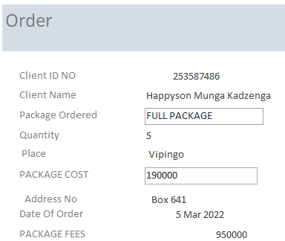

DATABASE SECURITY AND STARTUP OPTIONS.
To protect the database system from unauthorized access, Microsoft Access database management software, provides a number of options, these options include:
- Password protection
- User level security
- Data encryption
To setup any security options:
- Click tools menu.
- Point to security.
- Select the type of security you want to setup.

3.8.1 Password Protection
It the simplest security set up that can be implemented using any Microsoft Windows 10 Operating System. A password to open or edit the Database file is set for any user who wishes to do these actions.
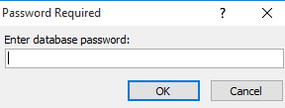
shows password dialog box.

3.8.2 User and Group Permission
Here, an administrator protects a database object such as reports, forms, and queries. These permissions opening and running the object, modifying. The user account is used to assign accounts to the database users.

3.8.3 User-level security
It is used to assign permission to user in order to limit access to certain database objects.

3.8.4 Data encryption
If the database is to be used in a network or sent electronically, encryption secures the data from unauthorized access. Only the intended recipient can use the decryption key to access the data.

3.8.5 Startup options
This is the last step in developing a customized application to specify start up options as shown below.
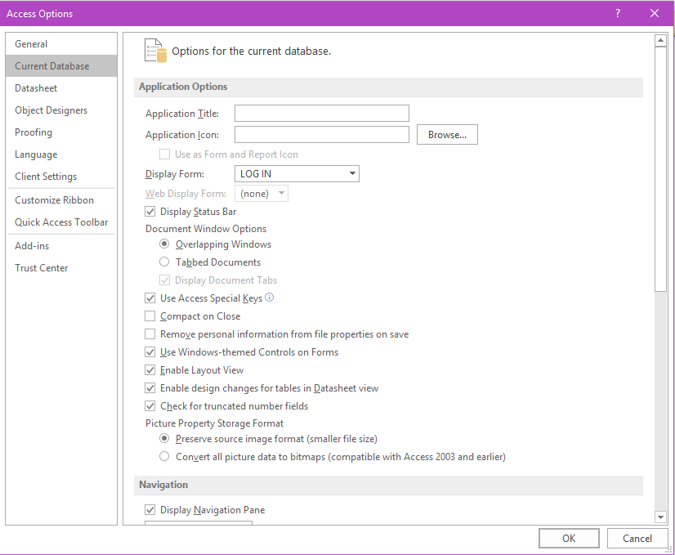

CHAPTER FOUR

TESTING AND IMPLEMENTING THE SYSTEM
The system modules were tested using test data and found to be working properly.

IMPLEMENTATION
Tasks involved during the implementation stage are:
- System management
- Staff training on how to use the new system
- Security control and contingency planning in case the system brakes down.
- Changing over from the old system to the new system.

TROUBLE SHOOTING DATA ENTRY AND RELATED ERRORS
Invalid data entry my result to error messages being prompted on the screen. Some errors that you may encounter are as follows;

Description: You are trying to enter the duplicate in the fields
Solution: Avoid entering duplicate data in the system i.e. the ID numbers of PLAYERs must be different.

Error message
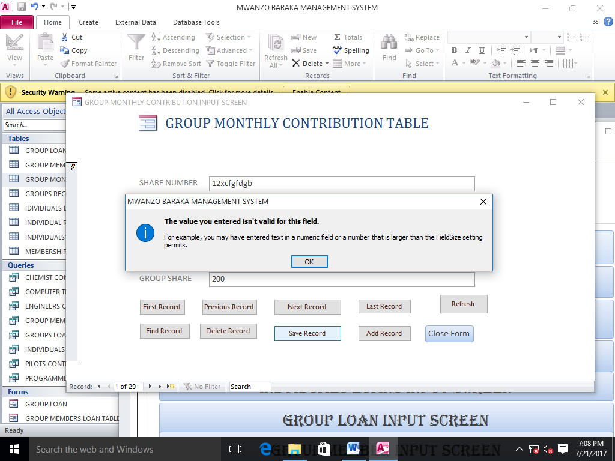

Error message3
Description: You are trying to enter different data type in the field for example text in a numeric field
Solution: Enter numbers for example 0-9

CHAPTER FIVE

USER MANUAL

INTRODUCTION
Maringo Sports Club System is a database used to keep up to date records of property and activities in the Maringo Organization. It also keeps the records of Players, Trainee and Trainer

5.2 INSTALLATION GUIDE

To install the Maringo Sports Club System, you need a genuine Windows 10 Operating system and database management system such as Microsoft office access 2016, enter the CD, click open, and then file menu and save as select desktop and then save.

5.3 LOUNCHING THE SYSTEM
To load the program:
Double click the application to open
Click sign in button

After click it will display a message
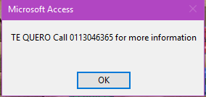

Click ok to continue
It will display the background with various buttons for the user to work with.

5.4 NAVIGATION GUIDE
When Maringo System it displays the startup dialog form. On startup dialog form is a button namely
Sign in-for starting the application
Sign out-for closing the system

PROCEDURE FOR GENERATING OUTPUTS
- Open the appropriate form
- Enter data values required in the form
- Click the tick sign
- Save by clicking save button

CHAPTER SIX

MISCELLANEOUS

CONCLUSION
Maringo Sports Club System is working efficiently in keeping well organized records of items and activities in the company and records of players, trainers’ and members in the company. It is able to monitor orders and their delivery and compute income, profit for the company and also payments to players.

RECOMMENDATION
The situate inventory system is not reliable and accurate. Therefore, as a system analyst, designer and developer, I recommend the Maringo Sports Club Organization to adopt the new computerized system that will meet all objectives.

APPENDICES OF THE PROJECT
Technical terms used in the documentation have been defined; also flowchart symbols have been clearly defined and explained.

Primary key: A key in a particular field that uniquely identifies records in a table.
Forms: They are graphical interface that enables faster entry of data in a table or viewing of records.
Queries: It is a tool that is used to extract details or records from a table or another query that meets a given criteria..

BIBLIOGRAPHY
It area contains reference materials used in developing the project
- DrJames Limon,: Introduction to Microcomputers and Programming, Information Systems Academy Ltd, 2000& 2020
- Microsoft Access 2010
- Stephen N. Mburu, Geoffrey W. Chekwa- Longhorn Secondary Computer Studies Form 4

